Creating Agent pool

Create virtual machine scale set
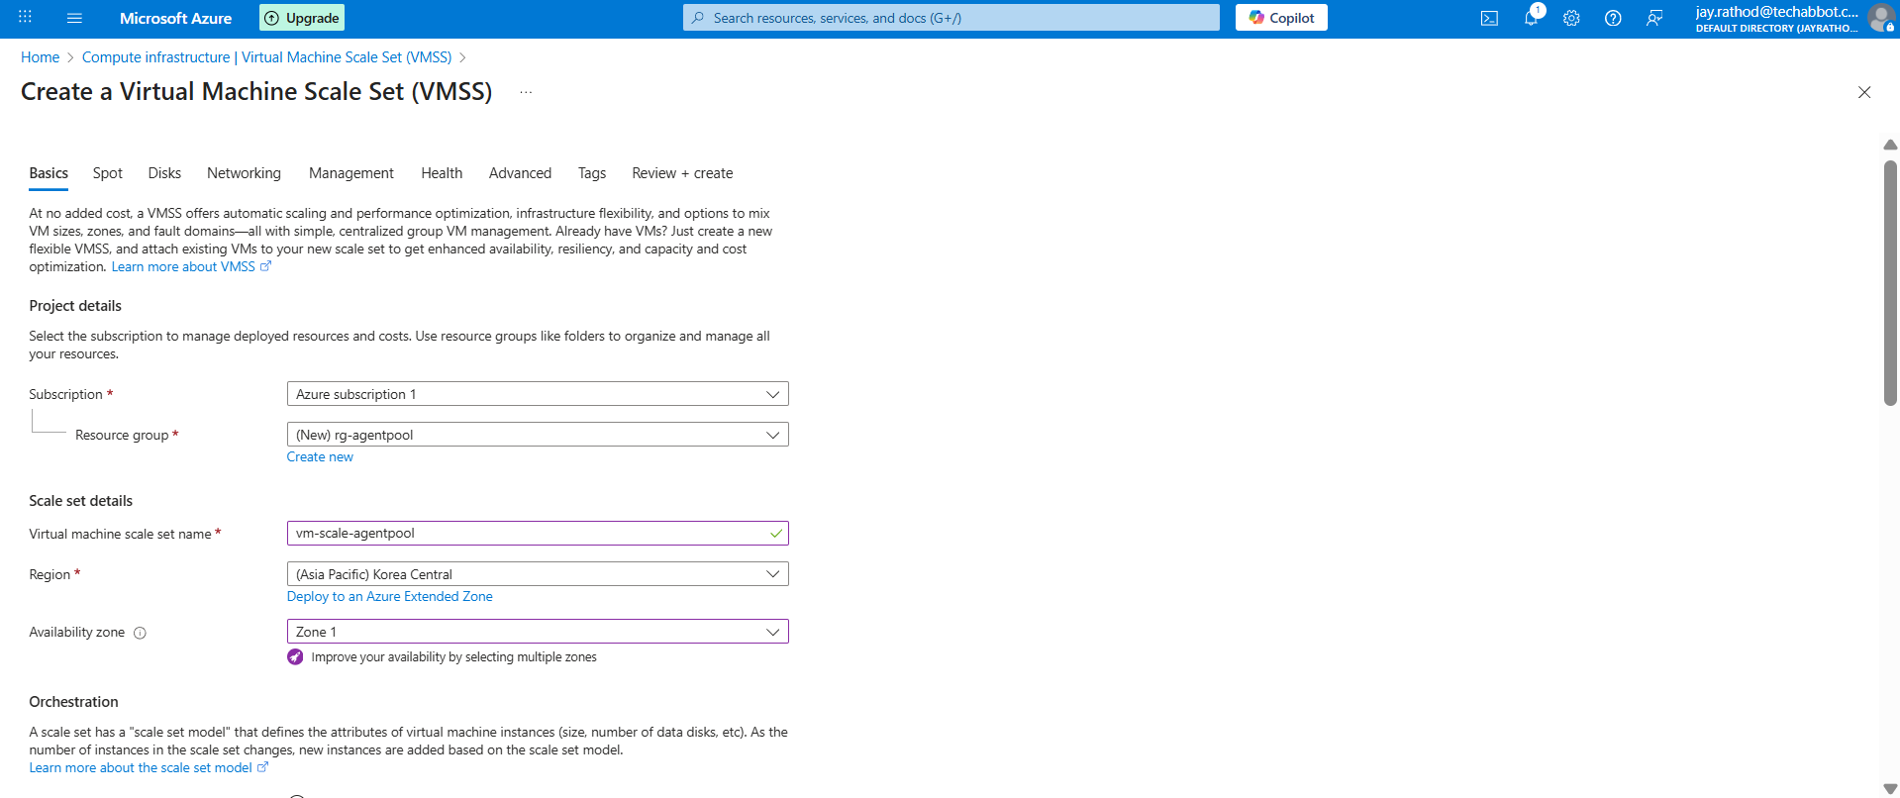
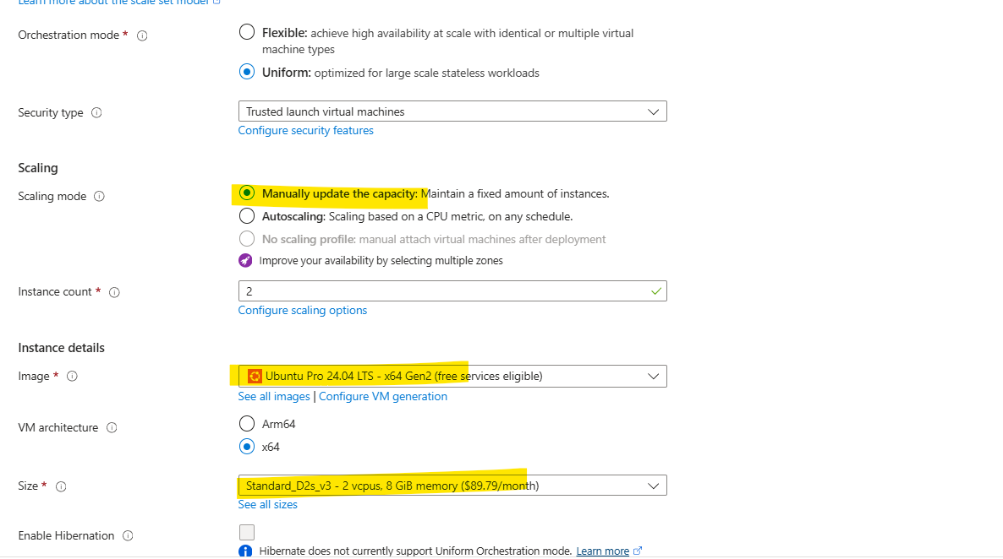

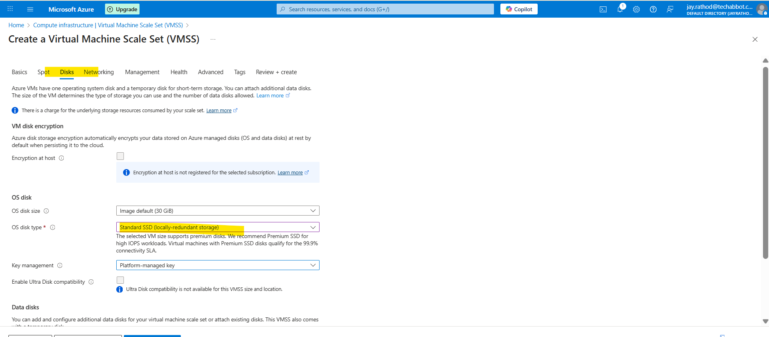

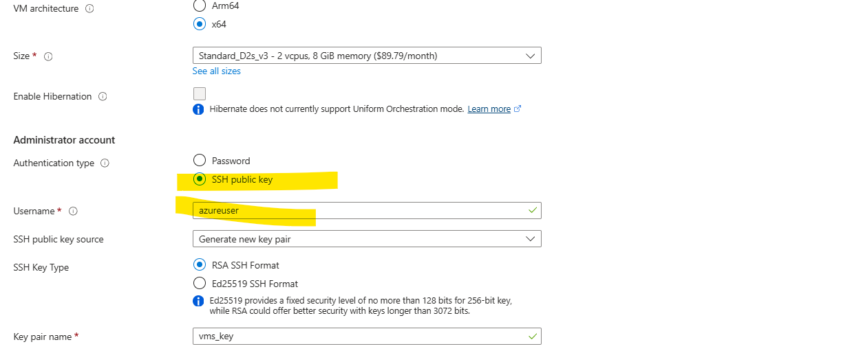

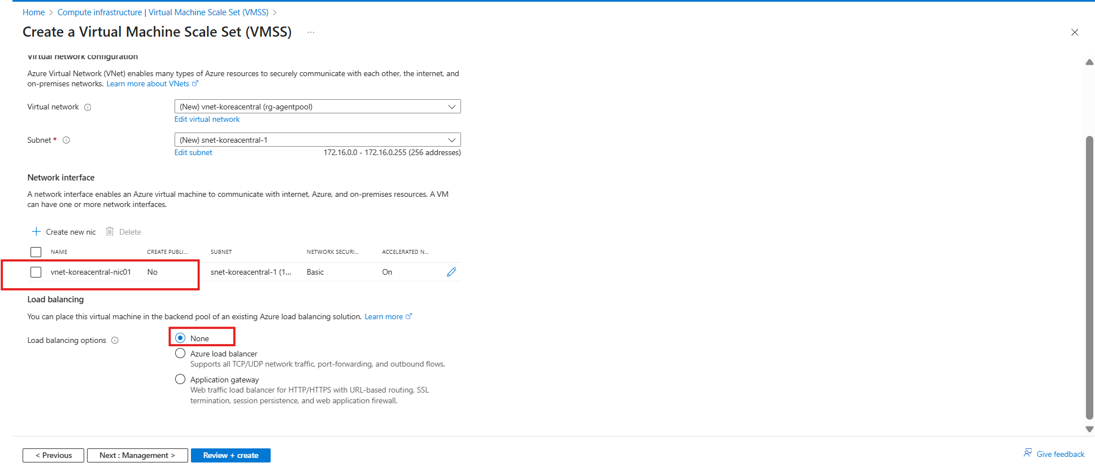
Upgrade mode = manual
Verify
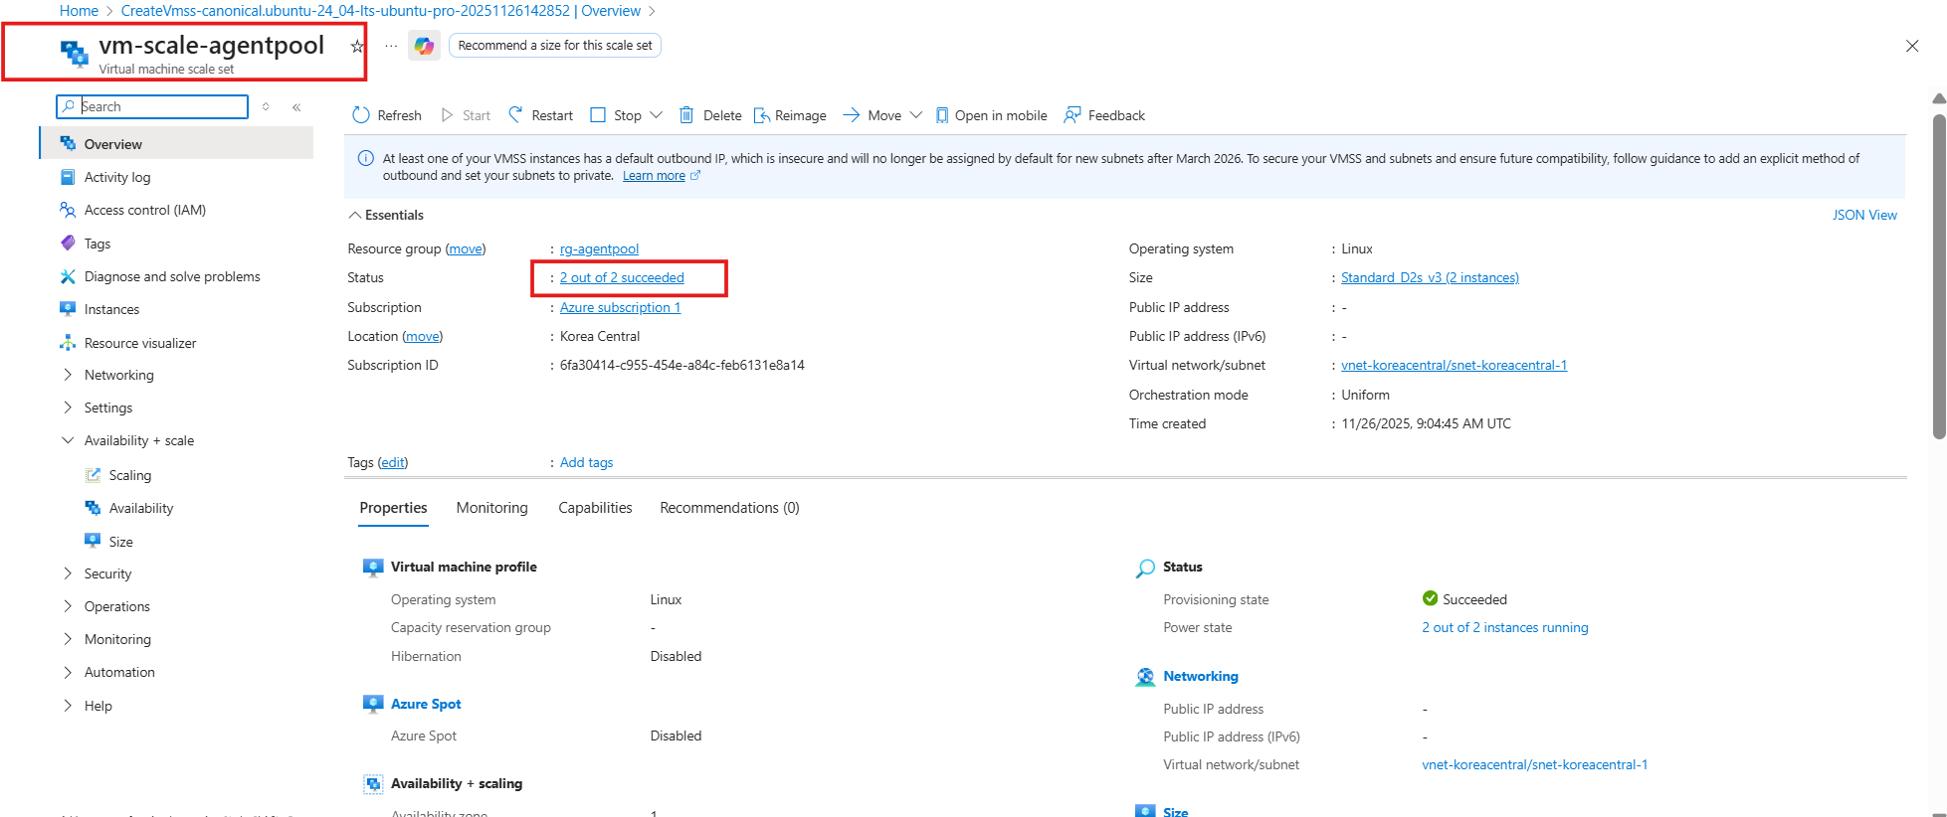
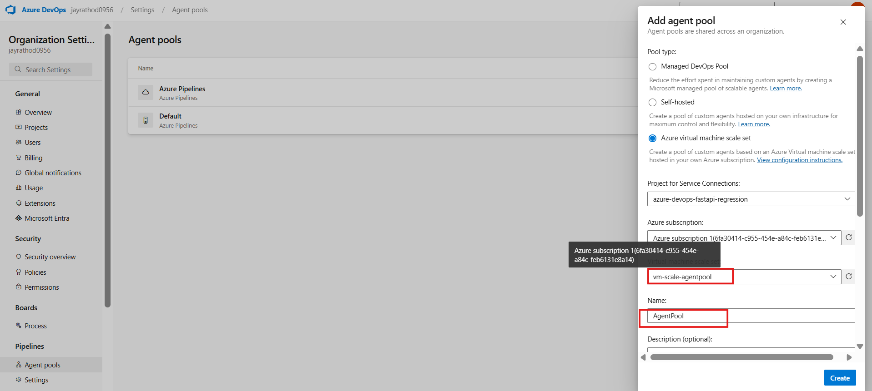
Max VM = 2 ,standby =1 ,delay = 1min
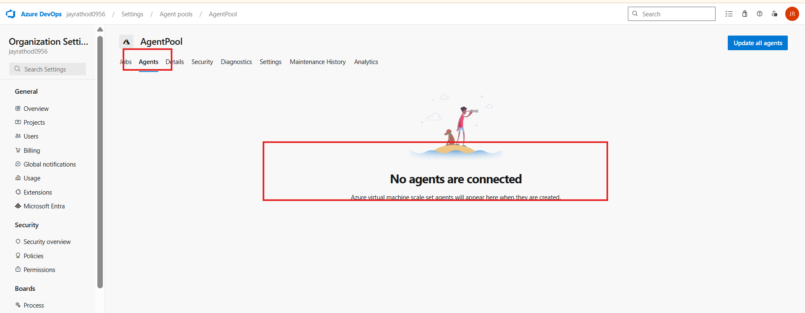
To configure from Vm set
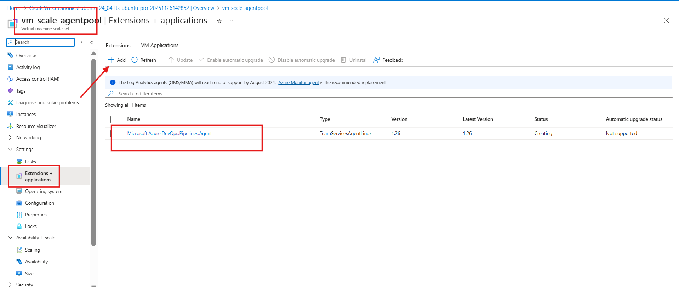
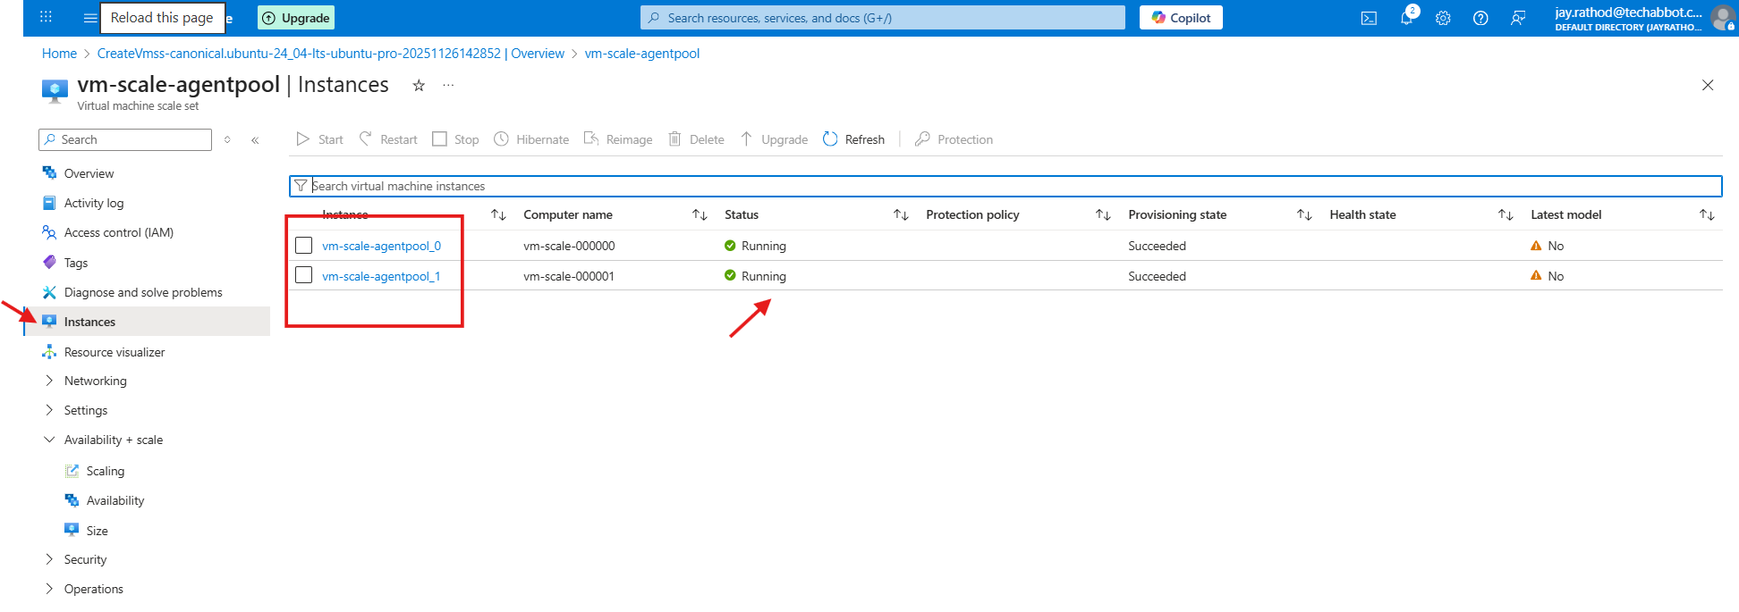
Wait for some time to reflect the changes on the agent pool screen : 10-15 min

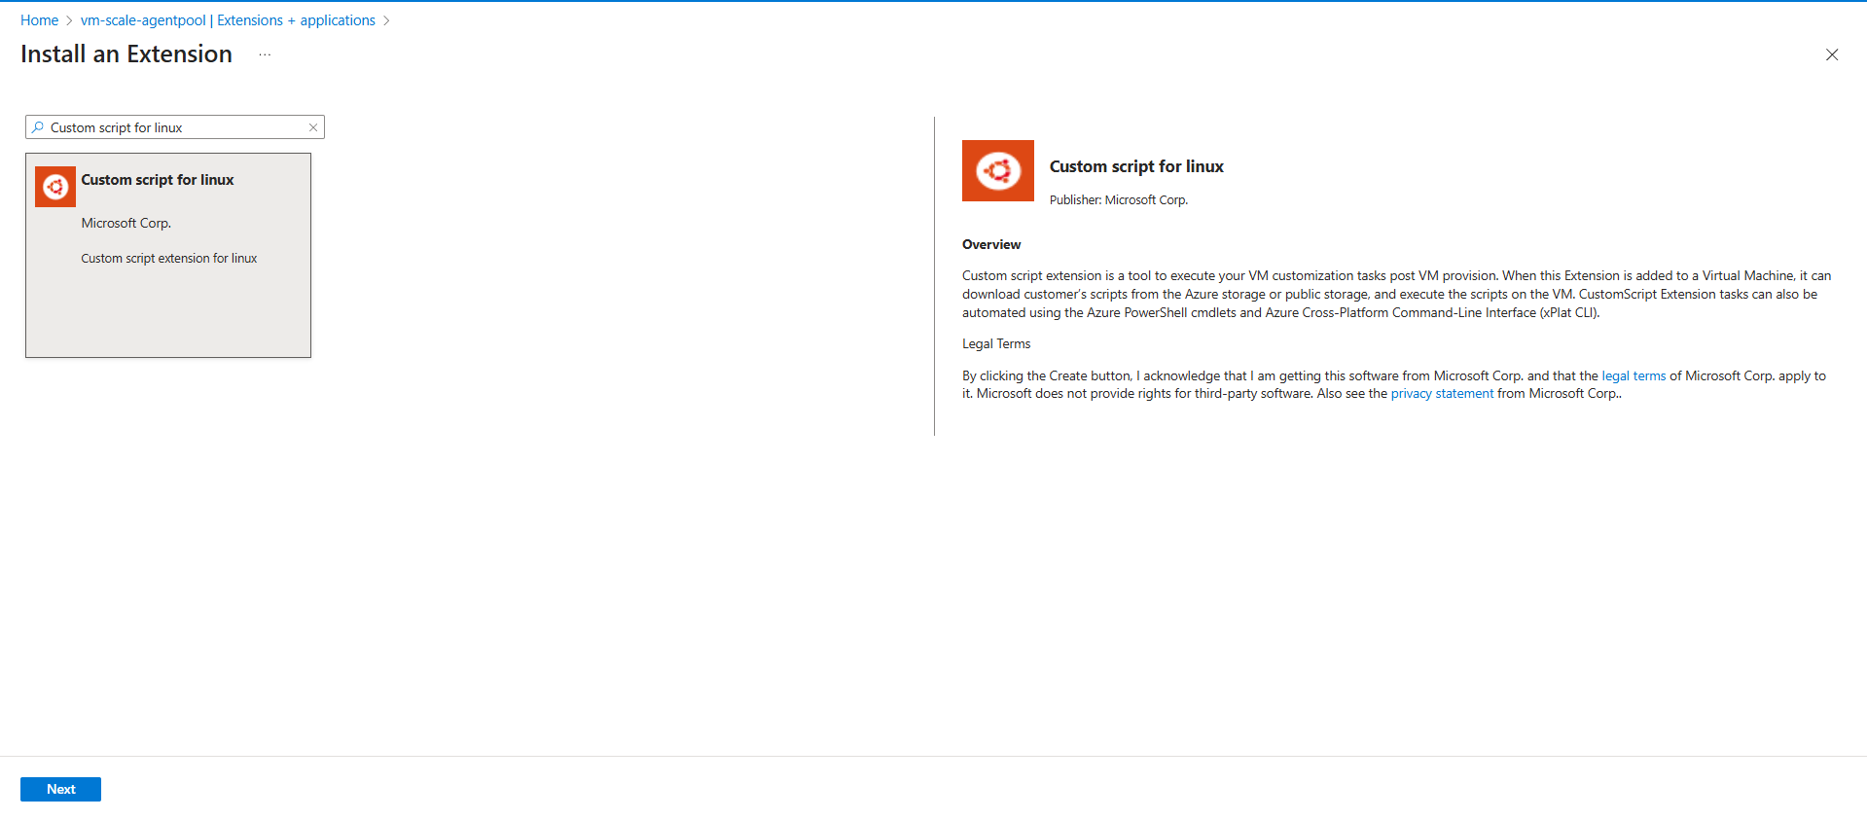
Add script through storage account
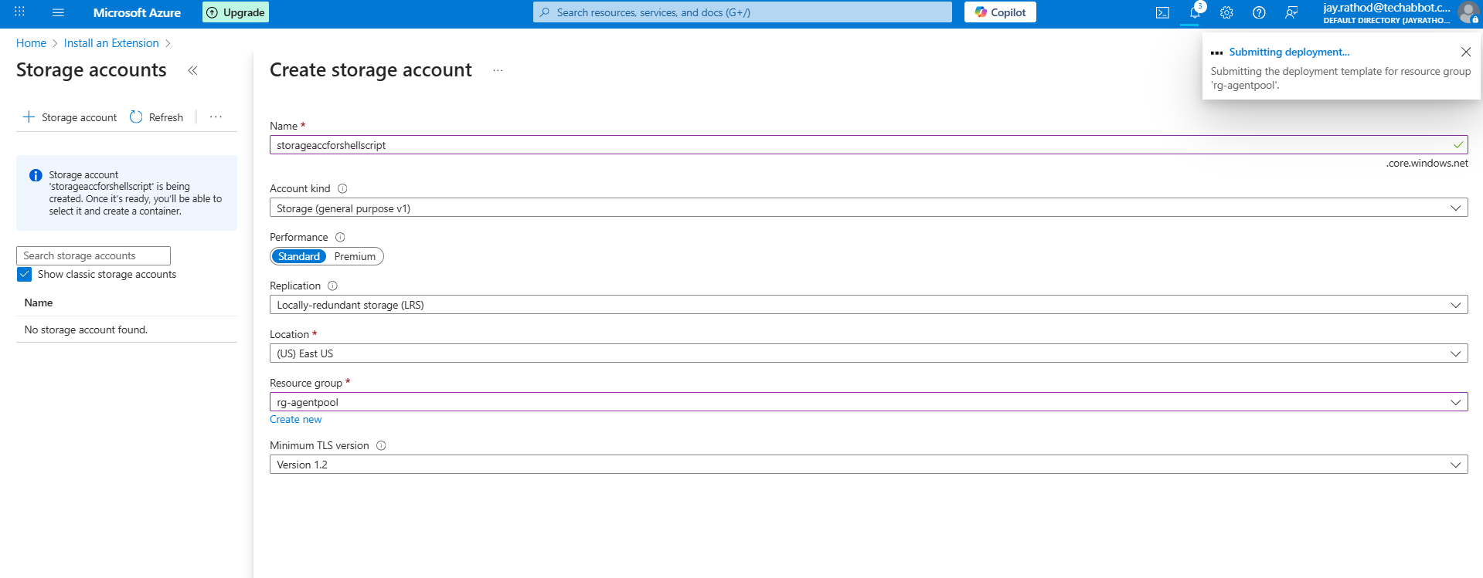
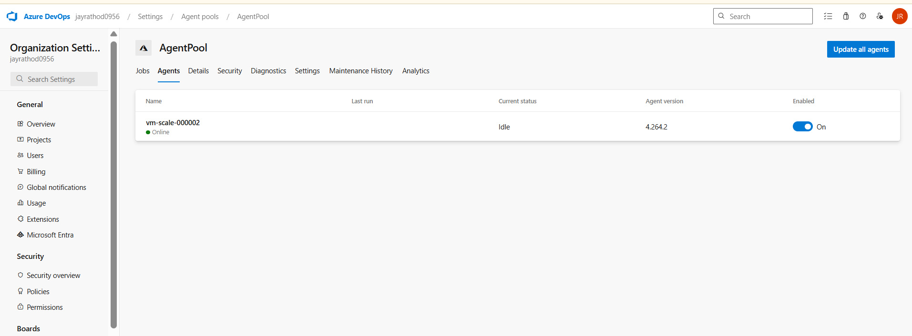

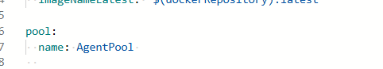

For adding custom script on the VM
#!/bin/bash
set -e

echo "🐳 Installing Docker Engine..."

sudo apt remove -y docker docker-engine docker.io containerd runc || true

sudo apt update -y
sudo apt install -y ca-certificates curl gnupg lsb-release

sudo install -m 0755 -d /etc/apt/keyrings
curl -fsSL https://download.docker.com/linux/ubuntu/gpg | sudo gpg --dearmor -o /etc/apt/keyrings/docker.gpg
sudo chmod a+r /etc/apt/keyrings/docker.gpg

echo \
"deb [arch=$(dpkg --print-architecture) signed-by=/etc/apt/keyrings/docker.gpg] https://download.docker.com/linux/ubuntu \
$(lsb_release -cs) stable" | sudo tee /etc/apt/sources.list.d/docker.list > /dev/null

sudo apt update -y

sudo apt install -y docker-ce docker-ce-cli containerd.io docker-buildx-plugin docker-compose-plugin

echo "🔧 Adding current user to docker group..."
sudo usermod -aG docker $USER

sudo systemctl start docker
sudo systemctl enable docker

echo "✔️ Docker Installed:"
docker --version || echo "⚠️ Docker installation issue"

#!/bin/bash
set -e

echo "🐍 Installing Python 3.12..."

sudo apt update -y
sudo apt upgrade -y

sudo apt install -y software-properties-common build-essential libssl-dev \
libffi-dev zlib1g-dev libbz2-dev libreadline-dev libsqlite3-dev wget curl \
llvm libncurses5-dev libncursesw5-dev xz-utils tk-dev libxml2-dev \
libxmlsec1-dev liblzma-dev

sudo add-apt-repository ppa:deadsnakes/ppa -y
sudo apt update -y

sudo apt install -y python3.12 python3.12-distutils python3.12-venv

curl -sS https://bootstrap.pypa.io/get-pip.py | sudo python3.12

echo "✔️ Python Installed:"
python3.12 –version
install-docker.sh
install-python.sh
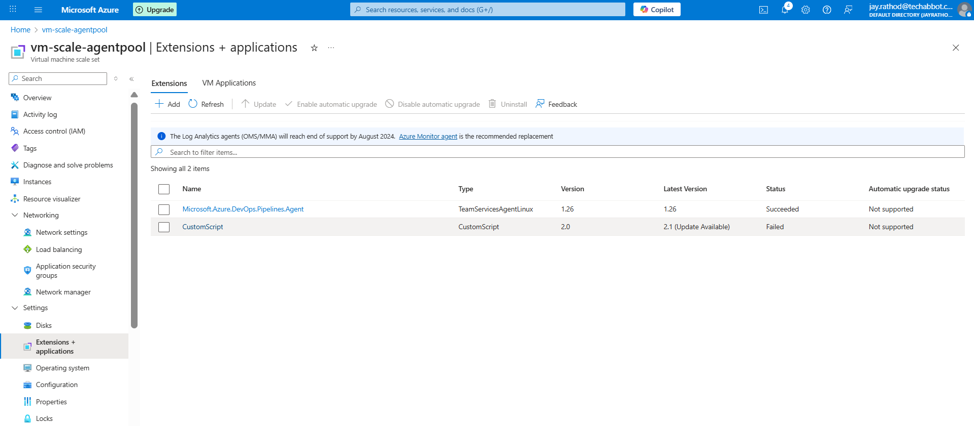

Command = sh <file>.sh && sh <file>.sh
Every time vm restart it will open new instant and forgot previously install packages.

Pipeline to verify python & docker
trigger:
enabled: false
pr:
enabled: false
stages:
- stage: __default
jobs:
- job: Job
pool:
name: AgentPool
steps:
- task: CmdLine@2
displayName: "Check Python & Docker Versions"
inputs:
script: |
echo "===== Checking Python Versions ====="
python3 --version || echo "python3 not found"
python3.12 --version || echo "Python 3.12 not installed"

echo ""
echo "===== Checking Docker Version ====="
docker --version || echo "Docker not installed or not accessible"

